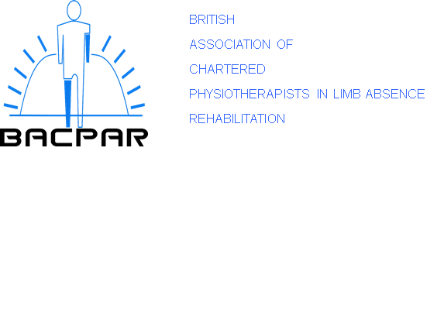

BACPAR Research Bursary Guidance
Introduction:
BACPAR are pleased to offer support grants to BACPAR members undertaking research or improvement projects, or to those seeking to develop knowledge and skills that would build towards or help progress a research career.
This bursary is intended to contribute to increasing research and improving capacity and capability within the field of limb absence rehabilitation by providing opportunities for people to investigate research questions and become clinical academics or independent researchers in the future.
These awards are available to support several different scenarios, all with the key aim of developing the evidence base within limb absence rehabilitation and having an impact on physiotherapy clinical practice. Potential funding scenarios are:
• Individuals who would like to undertake a research or improvement project within the field of Limb Absence Rehabilitation
- Research or improvement projects must be appropriate for this level of funding or demonstrate adequate support in place from other funding streams.
- Proposed projects should be relevant to current UK physiotherapy practice.
- Projects must demonstrate an ability to either contribute to the current evidence base or be working towards a larger project.
• Individuals who have an interest in research and improvement and need support to take the first steps along a clinical academic career pathway.
- The funding can be used to support an introduction to aspects of clinical research through gaining research experience by observing/visiting/working in a clinical research environment and undertaking study in research in preparation for applying for further MSc level courses.
- Individuals would need to demonstrate future clinical academic aspirations and support from their line managers.
• Researchers in the field who are further along in this pathway and are transitioning between MSc and PhD level study or beyond.
- The funding can be used to support grant writing for larger related research projects or clinical academic fellowships.

Eligibility:
- Full BACPAR membership for two consecutive years i.e. has been a member for at least one complete BACPAR year. Bursaries are not available to allied associate, departmental or student members. The research officers will, however, consider applications from individuals who may not be a full member of BACPAR if the proposed project will significantly influence physiotherapy practice or there are physiotherapists within the research team.

- 2. Each member may only submit one application per membership for each BACPAR financial year (July to June).

- Current registration to practice in the UK with the appropriate regulatory and professional bodies.

- Support from your employer/academic supervisor to undertake the proposed activity

How much is the support grant and how will the funding be used?
Each successful applicant will be awarded up to £3,000 to cover costs including:
- Salary Backfill
- Research project expenses - this could include anything related to the applied research objectives from patient and public involvement expenses, digital voice records, reference management systems, dictation services etc.
- Academic research supervision
- Formal research teaching i.e MRES modules or research methodology courses
- Dissemination costs i.e. via publications, blogs, videos, conference presentations etc.

The amount awarded will be paid directly to the appropriate party.
Evaluation
All successful applicants will be required to keep BACPAR informed of the progress of the award with regular updates, or any project findings reported at the executive committee meetings in March and Sept. They will be expected to provide at least one article for the journal as well as one of the following:
- A poster presentation for the BACPAR conference
- An oral presentation at the BACPAR conference
Application process:
Prior to applying it is recommended that the applicants contact the BACPAR research officers to discuss their plans. A bursary application form must be submitted, and these are available on the iCSP and BACPAR website.
Applications will be considered at the executive committee meetings in March and September, and it is advised that applications should be made as early in the financial year as possible to avoid disappointment.
If a member of the BACPAR Executive Committee applies for the bursary, then they will be asked to leave the meeting upon discussion of their application.
The outcome of the application will be communicated by email.

