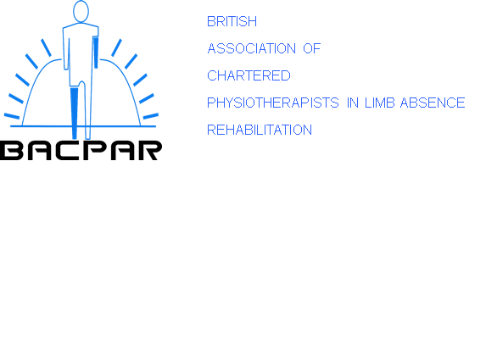

BACPAR Overseas Bursary Guidance
Introduction:
BACPAR are pleased to offer support grants to BACPAR members undertaking work abroad or assisting with healthcare in underprivileged countries, allowing them to pass on knowledge and skills that would build towards a service for those with limb absence.
This bursary is intended to contribute to improving capacity and capability within the field of limb absence rehabilitation by providing opportunities for people to either contribute to an already existing service or assist in setting up a service which would benefit those with limb absence.
These awards are available to support several different scenarios, all with the key aim of developing the evidence base within limb absence rehabilitation and having an impact on physiotherapy clinical practice. Potential funding scenarios are:
• Individuals who would like to undertake work abroad with a charity.
• Individuals who would like to assist in healthcare to upskill and existing service for those who have limb absence.
• Individuals who would like to volunteer within a conflict zone or an area in which there has been a disaster. The expectation is that this will be done under the auspices of a registered organisation for your safety.

Eligibility:
- Full BACPAR membership for two consecutive years i.e. has been a member for at least one complete BACPAR year. Bursaries are not available to allied associate, departmental or student members.

- Each member may only submit one application per membership for each BACPAR financial year (July to June).

- Current registration to practice in the UK with the appropriate regulatory and professional bodies.

- Support from your employer/academic supervisor to undertake the proposed activity.

How much is the support grant and how will the funding be used?
Each successful applicant will be awarded up to £1,000 to cover costs.
The amount awarded will be paid directly to the appropriate party.
Evaluation
All successful applicants will be required to keep BACPAR informed of the progress of the award with regular updates, reported to the executive committee meetings in March and Sept. They will be expected to provide one of the following:
- A poster presentation for the BACPAR conference
- An oral presentation at the BACPAR conference
- An article for the BACPAR journal
Application process:
Prior to applying it is recommended that the applicants contact the BACPAR secretary to discuss their plans. A bursary application form must be submitted, and these are available on the iCSP and BACPAR website.
Applications will be considered at the executive committee meetings in March and September, and it is advised that applications should be made as early in the financial year as possible to avoid disappointment.
If a member of the BACPAR Executive Committee applies for the bursary, then they will be asked to leave the meeting upon discussion of their application.
The outcome of the application will be communicated by email.

